

**VIETNAM NATIONAL UNIVERSITY**

**INTERNATIONAL SCHOOL**



**GROUP 2 FINAL REPORT**

***Title: Student Grade Management***

**CLASS : INS2080 - INS208001**

**LECTURER : Do Tien Thanh**

**GROUP : Group 2**

**MEMBER : Doan Duy Long – 22070843**

**Ma Thanh Tung – 22070904**

**Nguyen Quang Thai – 22070901**

**Dang Tran Tri Hieu – 22070981**

# 

# ACKNOWLEDGEMENT

I would like to express my sincere gratitude to everyone who has directly or indirectly helped and supported me throughout the project “Student Management”. Your contributions, big or small, have played a vital role in its success.

First and foremost the support and cooperation of the participants is also invaluable. Your willingness to share your knowledge and experiences, and your precious data, have formed the foundation for our analysis. You have played a vital role in ensuring the accuracy and reliability of our research.

My friends, who have been my companions on this research journey, also deserve special mention. Your constant support, encouragement, and insightful conversations have fueled my motivation and guided the development of the report. Your feedback has helped to refine the content of the report and improve its overall quality.

I would like to express my heartfelt thanks to the lecturers at VNU - IS. Their dedication in creating a supportive learning environment and providing us with a wealth of knowledge has been essential. They have laid the foundation for this project.

Finally, I would like to thank Professor Do Tien Thanh, my supervisor. His guidance, insightful feedback, and constant encouragement have been a constant source of inspiration for us throughout the research. He has created a space for us to think critically and creatively, and has helped us overcome every obstacle along the way.

I would like to express my sincere gratitude to all of you, even though I cannot name each individual who has helped to make this report a reality. Please know that your contribution, no matter how small, has been of great value. Thank you for being a part of this project.

Best regards!

Group 2

# TABLE OF CONTENT

ACKNOWLEDGEMENT 1

TABLE OF CONTENT 2

CHAPTER 1: INTRODUCTION. 4

1.1. Company Introduction 4

1.2. The ”SGM” system 5

1.2.1. Impact of the Cyberattack: 5

1.2.2. The Urgent Need for an Alternative Solution: 6

1.2.3. Benefits of a Student-Centric Solution: 6

1.2.4. Conclusion: 6

CHAPTER 2: BUSINESS DESCRIPTION 8

2.1. System requirement 8

2.1.1. User Management 8

2.1.2. Academic Organization and Management 9

2.1.3. Student Performance 9

2.1.4. Financial Management and Transparency 10

2.1.5. Communication and Security 10

2.2. Solution 10

CHAPTER 3: ERD AND RELATION 12

3.1. Explanation of the ERD Diagram 12

3.1.1. Entities: 12

3.1.2. Relationships: 13

3.2. Relations schema 15

CHAPTER 4: SQL STATEMENT 18

4.1. Create table 18

4.2. Insert values 23

4.3. Business questions and SQL solutions 31

CHAPTER 5: CONCLUSION. 40

5.1. Strengths of the SGM System: 40

5.2. Weaknesses of the SGM System: 40

5.3. Future Improvements for the SGM System: 40

PARTICIPANTS

**Đoàn Duy Long - 22070843:** Create tables and data for Grade,  School fee, Scholarship, and Event. Write Questions 6, 7, 8. Participate in making the report

**Ma Thanh Tùng - 22070904:** Create tables and data for Scholar_Major, Teacher_Major, Student_Scholar, and Student_Trainingpoint. Write Questions 9, 10. Participate in making the report

**Nguyễn Quang Thái - 22070901**: Create tables and data for the Teacher and Class. Write Questions 1, 2, 3. Participate in making the report

**Đặng Trần Trí Hiếu - 22070981:** Create tables and data for Major, Province and Student. Write Questions 4, 5. Participate in making the report

# **CHAPTER 1: INTRODUCTION.**

**HCM University of Technology and Education (HCMUTE)**

**Case study**

## 1.1. Company Introduction

**HCMUTE Management: A Student-Driven Response to a Digital Crisis**

The bustling halls of HCM University of Technology and Education (HCMUTE) in 2024 were a testament to the vibrant energy of its student body. However, this energy was disrupted by a recent cyberattack that crippled ASC, the university's primary provider of digital management solutions. This attack, exposing the data of 2,000 students, underscored a critical vulnerability: a reliance on a system susceptible to security breaches and disruptions.

The consequences were far-reaching. Students and faculty faced difficulties in accessing essential academic resources. Managing schedules, tracking grades, and maintaining clear communication channels became a frustrating exercise. Disruptions in these core functionalities threatened to hinder academic progress and create a sense of disarray within the HCMUTE community.

This crisis, however, ignited a spark of innovation in four enterprising HCMUTE students. Long, a visionary computer science major with a knack for leadership, recognized the opportunity. Joining forces with Tung, a marketing prodigy with a keen eye for branding, and Thai and Hieu, talented coders brimming with technical expertise, they embarked on a daring venture.

The problem they aimed to solve was multifaceted. The compromised ASC system lacked robustness, jeopardizing data security and hindering core functionalities. It also failed to prioritize user experience, creating a cumbersome and inefficient environment for students and faculty. The aftermath of the cyberattack exposed a critical need for a reliable, student-centric solution that could bridge the gap and restore seamless operations on campus.

HCMUTE Management, their brainchild, emerged as a response to this pressing need. Fueled by a shared passion for education and a commitment to their fellow students, the team envisioned a platform that would revolutionize the educational experience at HCMUTE. Their mission was clear: to empower students and faculty with a user-friendly platform that seamlessly integrated course management, scheduling, and communication tools.

Their vision extended beyond simply replicating existing functionalities. HCMUTE Management aimed to leverage technology to enhance efficiency, foster collaboration, and ultimately, promote academic success within the HCMUTE community. They envisioned a platform that would become the trusted partner for students and faculty navigating the ever-evolving digital landscape of education. Their goal: to ensure a seamless and enriching educational experience for all.

The problem they addressed wasn't merely a technical glitch; it was a missed opportunity to leverage technology for the betterment of education. HCMUTE Management, born out of this crisis, promised to become more than just a solution; it aimed to be a catalyst for a more efficient, secure, and collaborative learning environment at HCMUTE.

At the helm of the venture was Long, a visionary computer science major with a leadership talent. Alongside him were Tung, a marketing prodigy with a keen eye for branding, and Thai and Hieu, coding wizards who brought the technical expertise needed to develop a cutting-edge platform named “SGM”

## 1.2. The ”SGM” system

**A Cyberattack on the University's Digital Management System: The Urgent Need for a Student-Centric Solution**

A recent cyberattack on ASC, the university's digital management system, exposed critical vulnerabilities and caused significant disruptions for students and faculty. Students faced difficulties accessing essential academic resources, managing their course schedules, and communicating effectively. With ASC's services compromised, the university is in dire need of a reliable and student-centered solution to bridge the gap and restore seamless operations on campus.

### 1.2.1. Impact of the Cyberattack:

* **Disrupted Access to Learning Resources:** Students lost access to learning management systems, online lectures, the digital library, and other crucial learning materials. This resulted in substantial delays in their studies and completion of assignments.
* **Course Schedule Management Challenges:** Both faculty and students encountered difficulties in tracking course schedules, registering for classes, and managing their timetables. The lack of an effective scheduling system led to confusion and disorganization in academic planning.
* **Hindered Communication:** Online communication channels like email, discussion forums, and announcement systems were disrupted, making it difficult for students and faculty to exchange information, receive updates, and clarify doubts.

### 1.2.2. The Urgent Need for an Alternative Solution:

The cyberattack has undeniably highlighted the need for a more robust and reliable digital management solution for the university. This solution should fulfill the following criteria:

* **High Security:** The system must be equipped with advanced security measures to prevent future cyberattacks and safeguard student and faculty data.
* **User-Friendly Interface:** The user interface needs to be simple, intuitive, and easy to navigate for all students and faculty, regardless of their technical expertise.
* **Comprehensive Functionality:** The system should provide a complete set of features essential for academic management, including access to learning resources, course schedule management, and effective communication tools.
* **Student-Centric Design:** The system should be designed with the goal of addressing student needs and preferences, ultimately empowering them to achieve academic success.

### 1.2.3. Benefits of a Student-Centric Solution:

Implementing a student-centered digital management solution can yield numerous benefits for the university, including:

* **Enhanced Student Learning Experience:** Students will gain easy access to necessary learning resources, manage their schedules efficiently, and communicate effortlessly with instructors and peers.
* **Increased Faculty Efficiency:** Faculty members will be able to dedicate more time to teaching and research, instead of getting bogged down in tedious administrative tasks.
* **Improved University Operations:** More efficient management of information and processes will save the university time and resources while contributing to a higher quality of education.

### 1.2.4. Conclusion:

The cyberattack on ASC serves as a wake-up call for the university to prioritize a secure, reliable, and student-centered digital management system. Implementing such a solution will offer significant advantages for students, faculty, and the university as a whole, ultimately fostering a superior learning experience for everyone.

Mission: HCMUTE management is on a mission to revolutionize the educational experience at the HCM University of Technology and Education. Our goal is to empower students and faculty with a user-friendly platform that seamlessly integrates course management, scheduling, and communication tools. By leveraging technology, we aim to enhance efficiency, foster collaboration, and promote academic success within the HCMUTE community. Through innovation and dedication, we strive to be the trusted partner in navigating the digital landscape of education, ensuring a seamless and enriching experience for all. After many consideration they decided to use SQL as the framework for their development of the system

# **CHAPTER 2: BUSINESS DESCRIPTION**

This fictional database system, created by HCMUTE students, focuses on:

- **Improved Student Management:** SGM could streamline processes like registration, grade tracking, and communication between students and faculty.

- **Enhanced Security:** Considering the data breach mentioned in the case study, SGM might prioritize robust security features to protect student information.

- **Streamlined Communication:** The platform could facilitate communication channels between students, faculty, and administration.

Possible Features of the HCMUTE Database (if it existed):

- **Student Information:** Secure storage of student data (likely with opt-in permissions) including demographics, academic records, and contact information.

- **Course Management:** Information on course offerings, registration, and faculty details.

- **Grades and Transcripts**: Access to grades, transcripts, and academic progress reports.

- **Financial Aid:** Management of scholarships, financial aid applications, and fee payments.

**- Communication Tools:** Secure messaging system for faculty-student interaction and university announcements.

**- Career Services**: Job posting platform, career counseling resources, and alumni networking tools (if applicable).

**- Library Resources**: Access to online library resources and digital materials.

## 2.1. System requirement

**SGM System Requirements: A Comprehensive Overview**

### 2.1.1. User Management

* **Student Profiles:** The system shall securely store and manage student information. This includes:
  + Biographical details: Name, date of birth, address, phone number, and email address.
  + Educational details: Enrollment status, academic major, and program track.
* **Faculty Profiles:** Similar to student profiles, SGM will establish secure profiles for faculty members, encompassing:
  + Personal information: Name, date of birth, contact details (phone number and email).
  + Professional details: Academic qualifications, departmental affiliation, and courses taught.

### 2.1.2. Academic Organization and Management

* **Academic Programs and Courses:** The system shall create and maintain a comprehensive list of:
  + Academic programs (majors) offered by the institution.
  + Courses associated with each program, including detailed descriptions, assigned instructors, and any prerequisites.
  + Course materials and resources accessible to enrolled students.

### 2.1.3. Student Performance

* **Grade Management:** The system must allow faculty to efficiently record and display student grades in various courses. This includes:
  + Support for diverse grading schemes (e.g., letter grades, percentages).
  + Easy entry of grades with minimal data redundancy.
  + Automatic calculation of student GPA based on recorded grades.
  + Secure access for both students and teachers to view grades.
* **Extracurricular Activity Management:** SGM will track student participation in extracurricular activities, fostering well-rounded development. This includes:
  + A comprehensive list of available extracurricular activities (clubs, sports, community service initiatives, etc.).
  + Recording student participation levels and tracking their commitment over time.
  + Potential for integrating achievements or awards earned through extracurricular involvement.
* **Conduct Grade Management:** SGM goes beyond academics by recording and tracking students' conduct grades. This encompasses:
  + Evaluation based on participation in extracurricular activities, behavior within the school environment, and adherence to established rules.
  + Documented records of conduct concerns or disciplinary actions (if applicable).

### 2.1.4. Financial Management and Transparency

* **Tuition Fee Management:** The system will provide clear and detailed financial information for students, including:
  + Accurate tracking of tuition fees associated with their academic program.
  + Access to invoices and statements reflecting outstanding fees or completed payments.
  + Information on available financial aid options and loan programs (if applicable).

### 2.1.5. Communication and Security

* **Communication and Notification Tools:** Recognizing the importance of clear communication, SGM will offer robust features for interaction between students, faculty, and administrators. This includes:
  + A secure messaging system for sending targeted or group messages.
  + Tools for distributing announcements, updates about events, schedule changes, and important university information.
* **Data Security:** SGM prioritizes the protection of sensitive personal information. The system will employ robust security measures to ensure:
  + Secure storage of student and faculty data in compliance with all applicable data protection regulations.
  + User authentication and access control mechanisms to prevent unauthorized access.
  + Regular security audits and updates to mitigate potential vulnerabilities.

## 2.2. Solution

* Revealing this data not only affects the company's reputation but also poses the risk of fraud, theft of personal information and financial harm to customers.
* A team of security experts quickly launched an investigation. After hours of tracing, they discovered that the attacker had been using malware to infiltrate the system, steal data, and remain invisible for months.
* This incident is a wake-up call for ASC about security holes in the system. To overcome the consequences and prevent similar attacks in the future, the expert team has taken the following measures:
* Update software and operating systems: update all software and operating systems to the latest versions to patch discovered security vulnerabilities.
* Install anti-virus and anti-malware software: install advanced anti-virus and anti-malware software to protect your system from new threats.
* Enhance password security: ask customers to learn to use strong passwords and change passwords regularly.
* Raise awareness of cyber security: organize cyber security training courses for employees to raise awareness of cyber threats and how to protect themselves.
* Backup data regularly: perform regular data backups to ensure data can be restored in case of an attack.

# **CHAPTER 3: ERD AND RELATION**

## **3.1. Explanation of the ERD Diagram**

The provided ER diagram represents a university management system that encompasses various entities related to student information, academic data, and financial management. Let's break down the key components:

### 3.1.1. Entities:

* **Student:** Represents students enrolled at the university. Attributes include student ID, name, date of birth, address, phone number, email, and major ID.
* **Teacher:** Represents faculty members teaching at the university. Attributes include teacher ID, name, date of birth, address, phone number, email, and major ID.
* **Major:** Represents academic majors offered by the university. Attributes include major ID, major name, and department ID.
* **Course:** Represents courses offered within the university's academic programs. Attributes include course ID, course name, credit hours, and department ID.
* **Class:** Represents instances of specific courses offered in a particular semester. Attributes include class ID, course ID, semester, and teacher ID.
* **Grade:** Represents the grades obtained by students in specific courses. Attributes include grade ID, student ID, class ID, daily score, midterm score, final score, and total score.
* **Scholarship:** Represents scholarships offered to students based on various criteria. Attributes include scholarship ID, scholarship name, scholarship prize, and major ID.
* **Student Scholar:** Represents the association between students and the scholarships they have received. Attributes include student ID, scholarship ID, and semester.
* **Tuition Fee:** Represents the tuition fees associated with each course. Attributes include tuition fee ID, class ID, school fee, and other fee.
* **Schoolfee:** Represents the different types of school fees associated with tuition. Attributes include schoolfee ID, schoolfee name, and other fee name.
* **Province:** Represents the provinces where students reside. Attributes include province ID, province name, and other province information.
* **Student Trainingpoint:** Represents the training points or extracurricular activities associated with students. Attributes include student ID, TID, event ID, event position, paint, and other training point information.
* **Event:** Represents events or competitions organized by the university. Attributes include event ID, event name, and event position.
* **Have_Paid:** Represents whether the tuition fee has been paid by the student. Attributes include student ID, class ID, semester, and have_paid status.

### 3.1.2. Relationships:

* **Student-Major:** A student can belong to one major.
* **Teacher-Major:** A teacher can belong to one major.
* **Department-Course:** A department offers multiple courses.
* **Course-Class:** A course can have multiple instances or classes offered in different semesters.
* **Class-Teacher:** A class is taught by one teacher.
* **Student-Class:** A student can enroll in multiple classes.
* **Class-Grade:** A class has multiple grades associated with it.
* **Student-Scholarship:** A student can receive multiple scholarships.
* **Scholarship-Major:** A scholarship can be associated with a specific major.
* **Student-Student Scholar:** A student's scholarship is associated with a specific semester.
* **Class-Tuition Fee:** A class has associated tuition fees.
* **Student-Province:** A student resides in one province.
* **Student-Student Trainingpoint:** A student can participate in multiple training points or extracurricular activities.
* **Event-Student Trainingpoint:** A training point or extracurricular activity is associated with one event.
* **Student-HavePaid:** A student may have paid tuition fees for a particular class and semester.

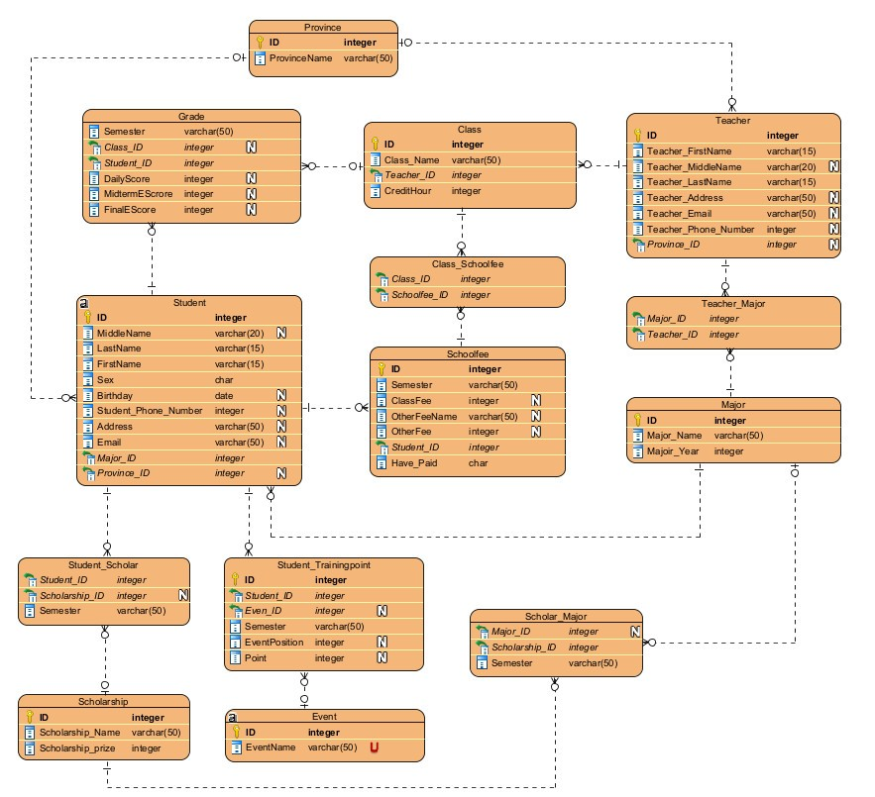

## **3.2. Relations schema**

**Table name : major**

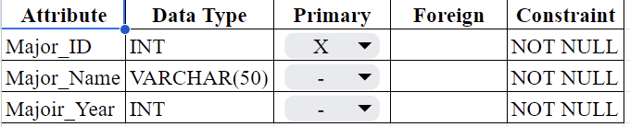

**Table name : province**

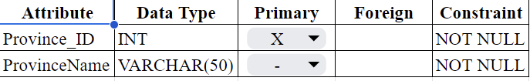

**Table name : student**

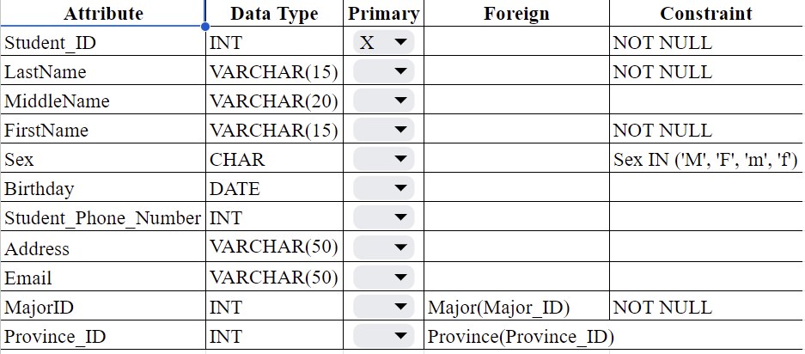

**Table name : student_scholar**

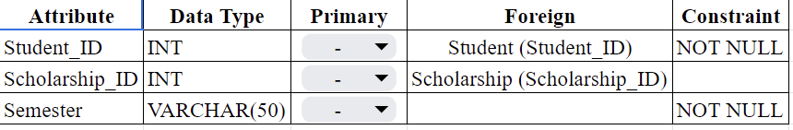

**Table name : teacher**

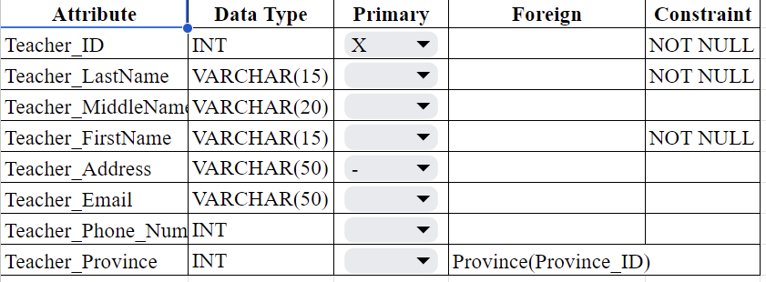

**Table name : class**

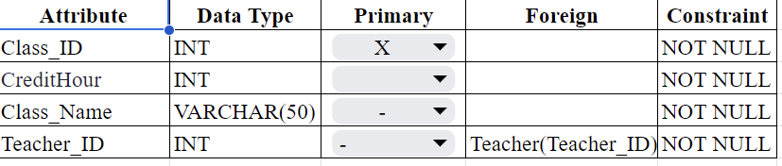

**Table name : grade**

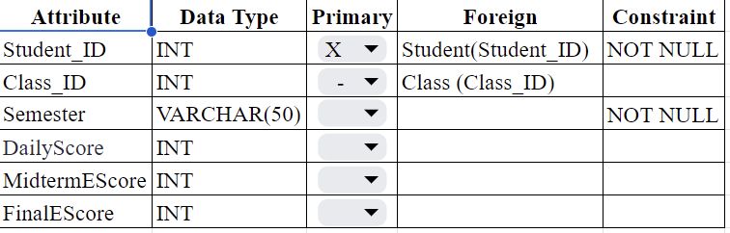

**Table name : scholarship**

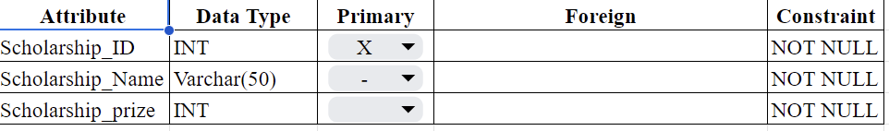

**Table name : school fee**

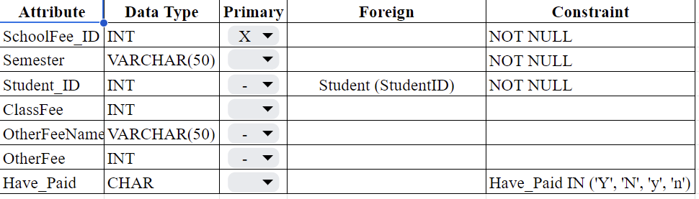

**Table name : event**

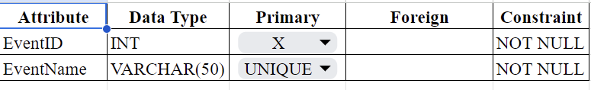

**Table name : scholar_major**

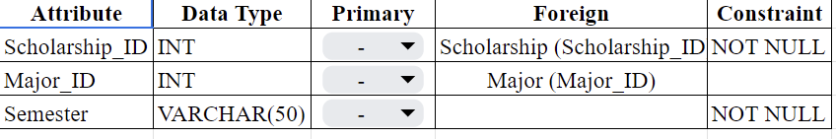

**Table name : teacher_major**

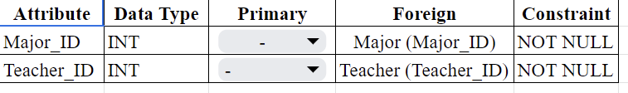

**Table name : student_trainingpoint**

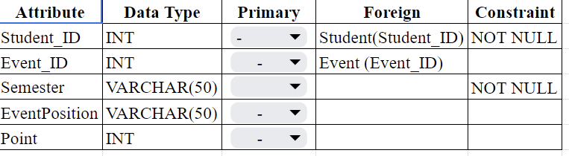

# **CHAPTER 4: SQL STATEMENT**

## **4.1. Create table**

* **Major**

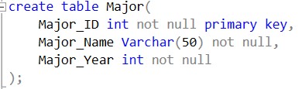

Result :

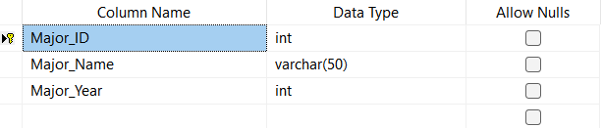

* **Province**

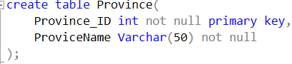

Result :

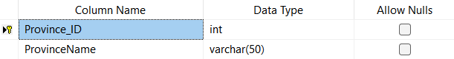

* **Student**

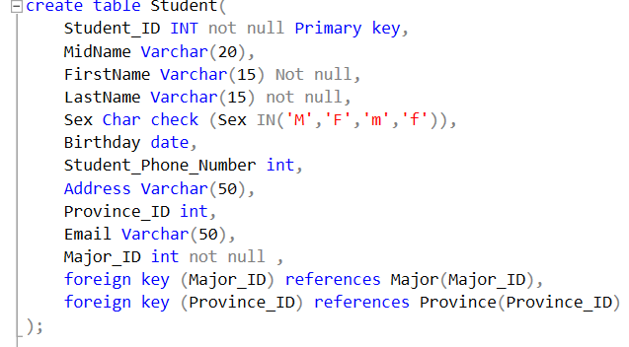

Result :

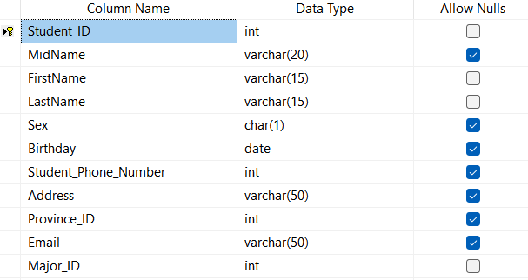

* **Teacher**

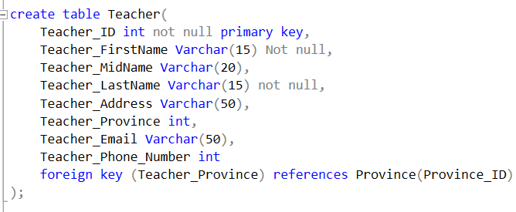

Result :

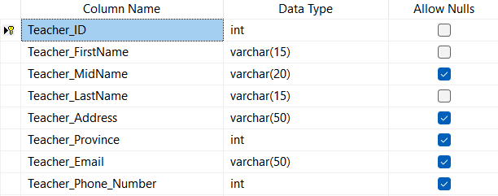

* **Class**

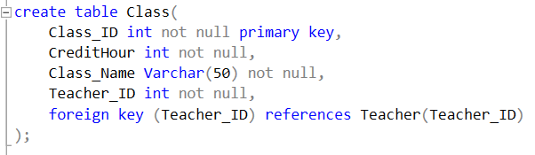

Result :

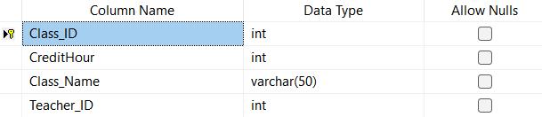

* **Grade**

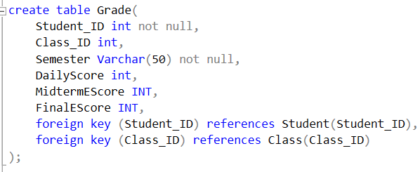

Result :

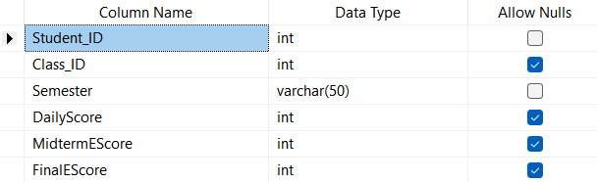

* **Schoolfee**

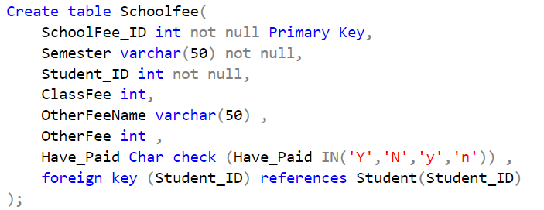

Result :

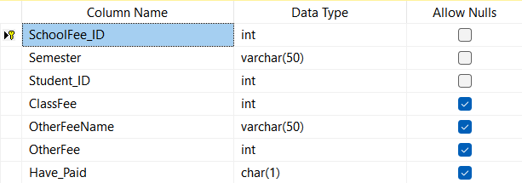

* **Scholarship**

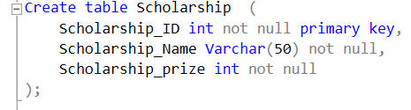

Result :

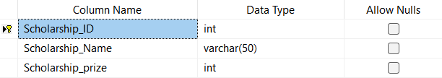

* **Event**

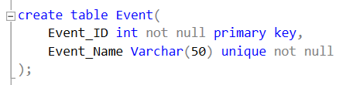

Result :

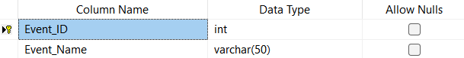

* **Scholar Major**

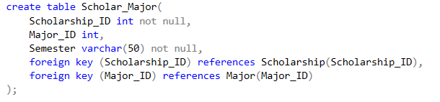

Result :

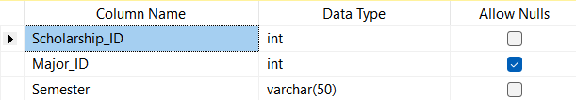

* **Teacher Major**

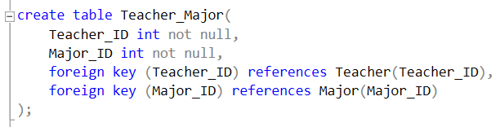

Result :

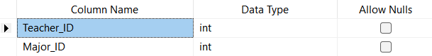

* **Student scholar**

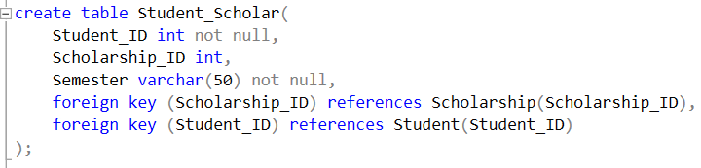

Result :

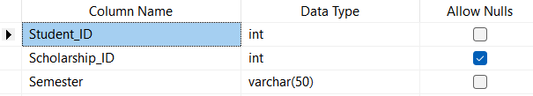

* **Student Training point**

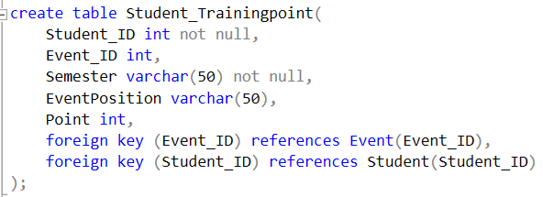

Result :

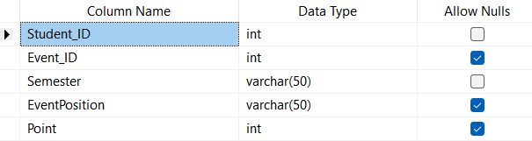

## **4.2. Insert values**

Notice: The following code and data have been cut off for visualization. It’s not the comple version of the code and data

* **Major**

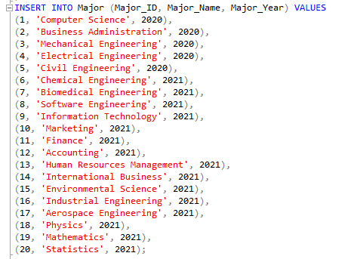

Result:

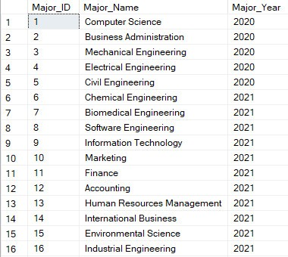

* **Province**

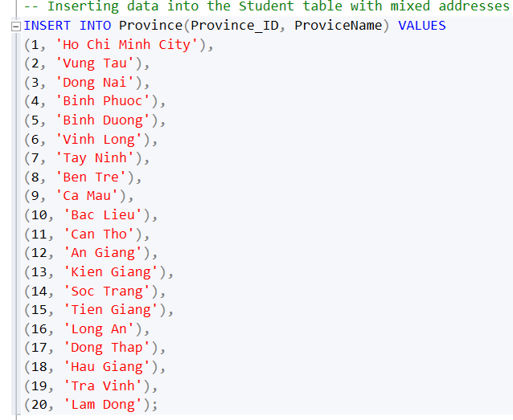

Result :

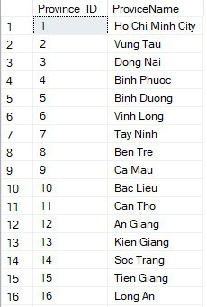

* **Student**

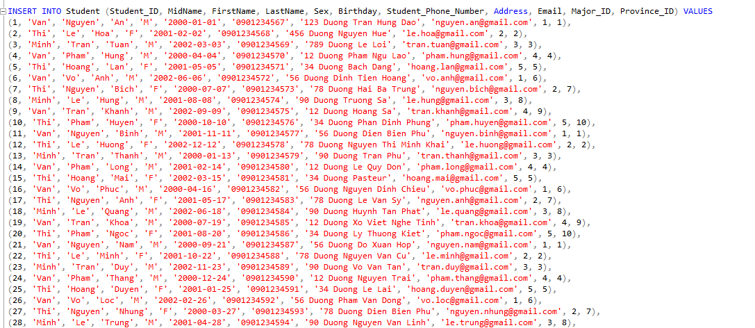



Result :

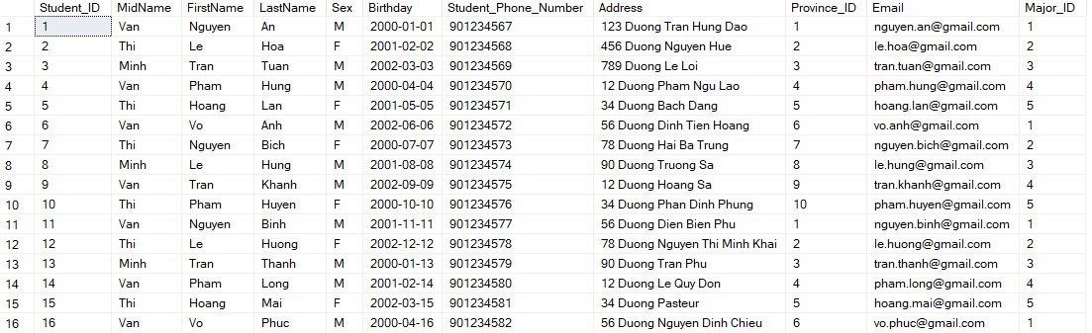

* **Teacher :**

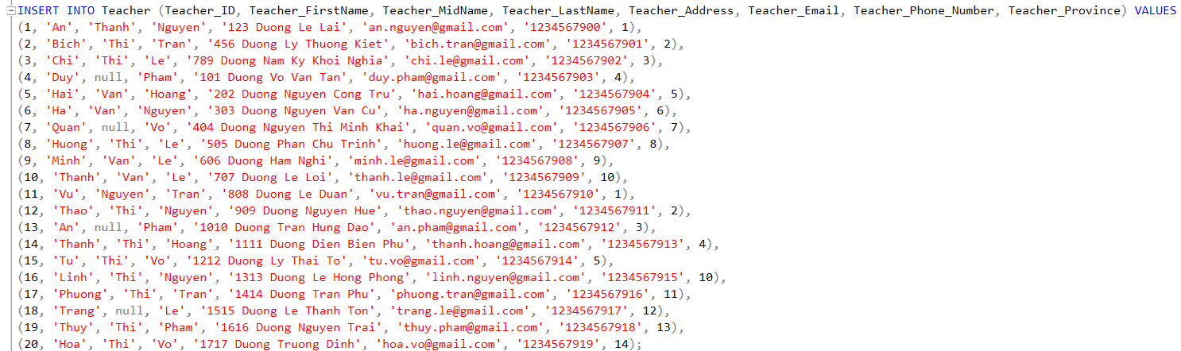





Result :

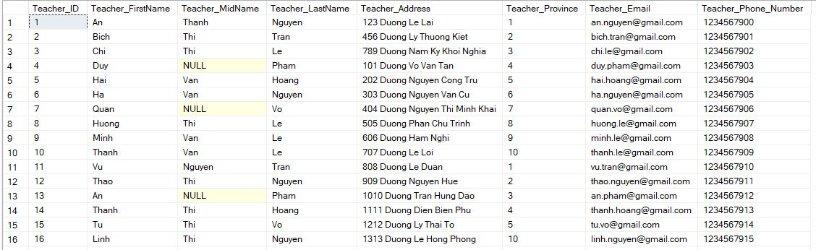

* **Class**

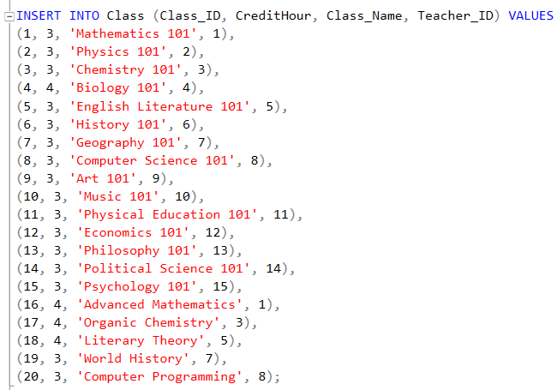

Result :

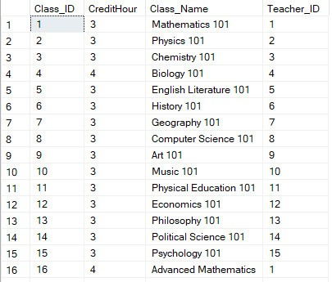

* **Grade**

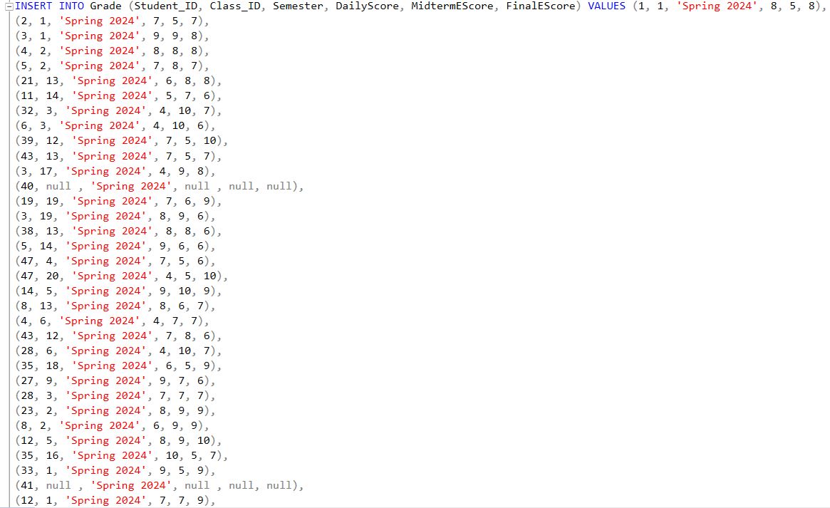

Result :

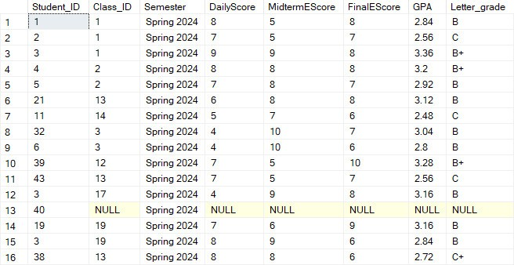

* **School fee**

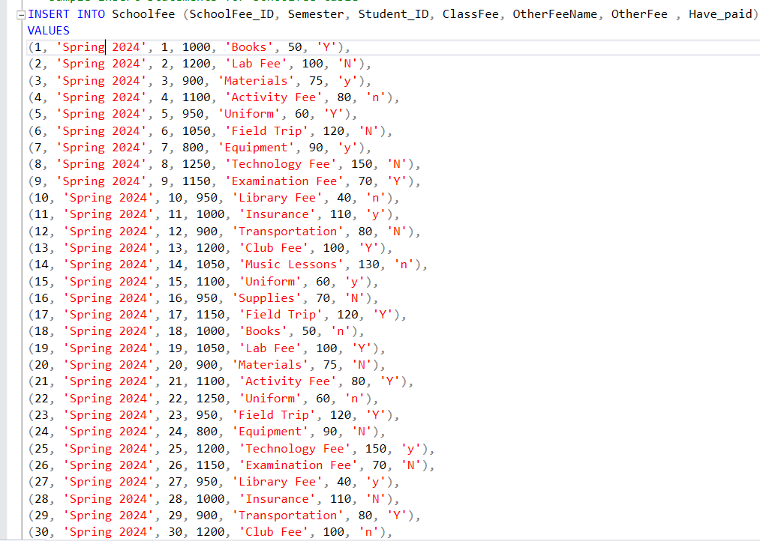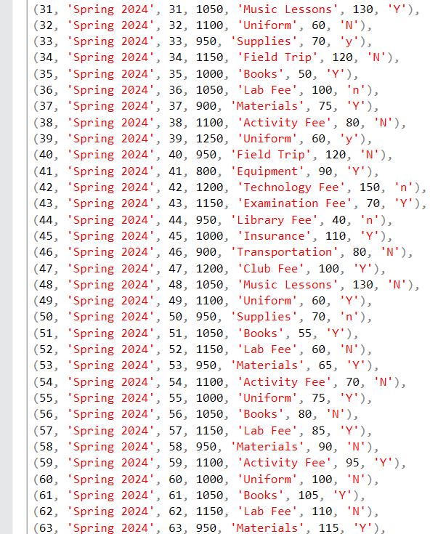

Result :

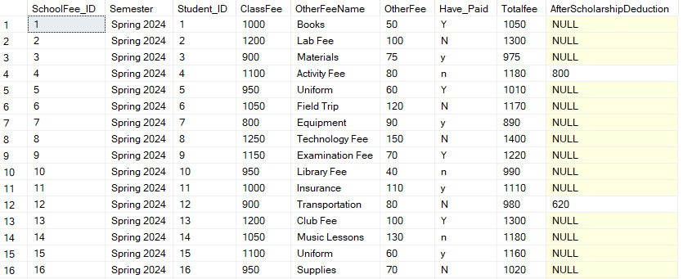

* **Scholarship**

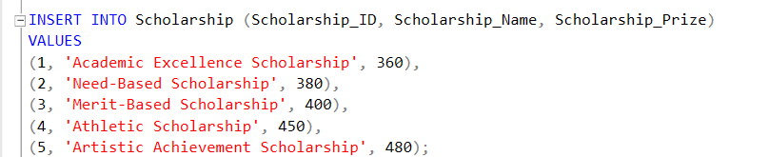

Result :

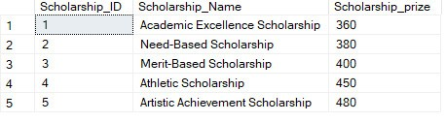

* **Event:**

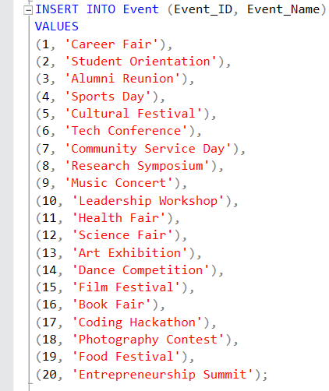

Result:

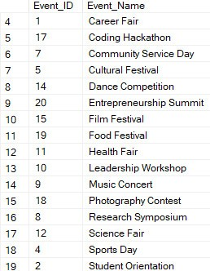

* **School Major**

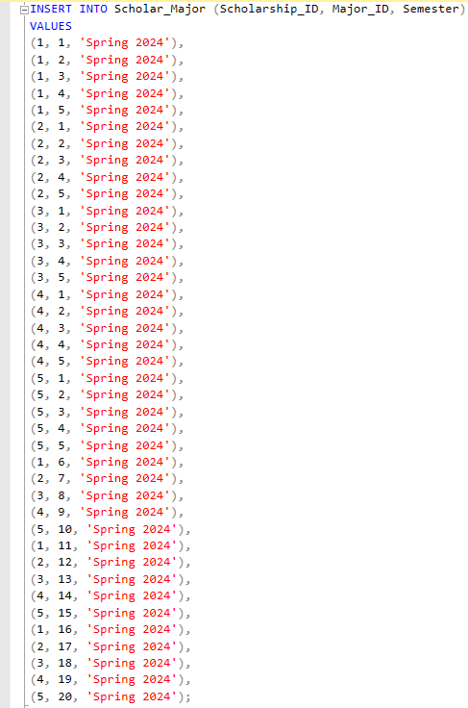



Result

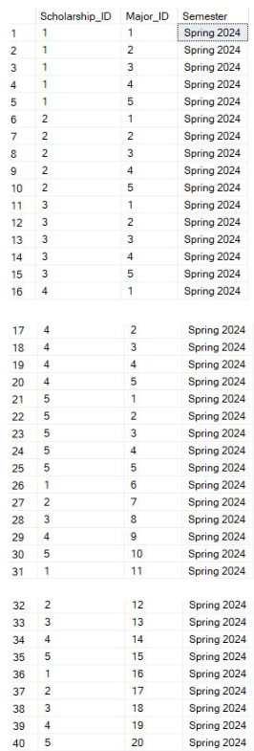

* **Teacher Major**

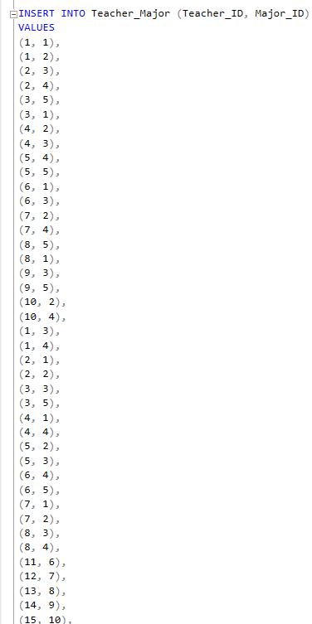

Result

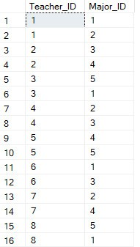

* **Student training point**

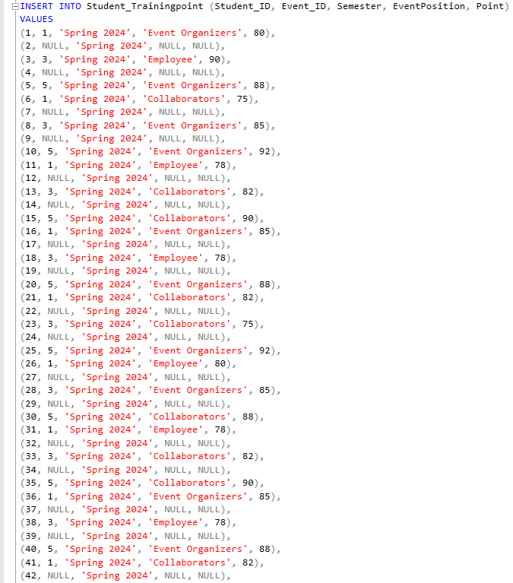

Result :

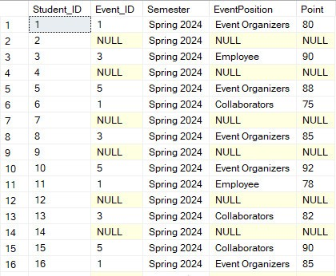

## **4.3. Business questions and SQL solutions**

**Question 1: List student who major_id is 1**



* **SELECT ... FROM Student:** Selects data from the ‘Student’ table.
* **where Major_ID = 1:** Filters the results to include only students with ‘Major_ID’ of 1.
* **Result :**

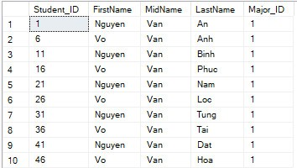

**Question 2 : List student is male and birthday is after 2000**



* **SELECT ... FROM Student:** Selects data from the ‘Student’ table.
* **WHERE (Sex = 'm' or Sex = 'M') AND Birthday > '2000-12-31':** Filters the results to include only students  **‘**Sex’ is male and ‘Birthday’ after 2000
* **Result :**

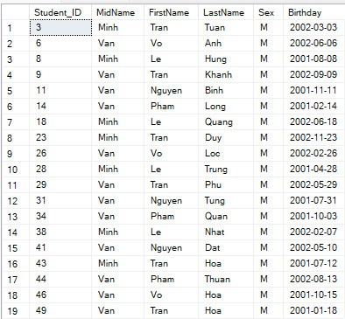

**Question 3 : Count the number of students in each province**

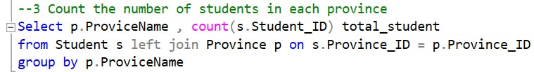

* **SELECT p.ProvinceName, COUNT(s.Student_ID) AS Total_Student:** Selects the province name and counts the number of students in each province. The count of Student_ID is given an alias Total_Student for clarity.
* **FROM Student s LEFT JOIN Province p ON s.Province_ID = p.Province_ID:** Performs a left join between the Student table and the Province table based on the Province_ID field.
* **GROUP BY p.ProvinceName:** Groups the results by ProvinceName to aggregate the student count for each province.
* **Result:**

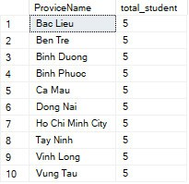

**Question 4: List the name of students who have no training point**

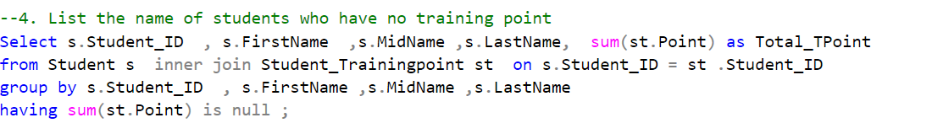

* **SELECT s.Student_ID, s.FirstName, s.MidName, s.LastName, SUM(st.Point) AS Total_TPoint:** Selects the student ID, first name, middle name, last name, and the total training points .
* **FROM Student s INNER JOIN Student_Trainingpoint st ON s.Student_ID = st.Student_ID:** Uses a inner join to include all students from the Student table .
* **GROUP BY s.Student_ID, s.FirstName, s.MidName, s.LastName:** Groups the results by student ID, first name, middle name, and last name to calculate the sum of points per student.
* **HAVING SUM(st.Point) IS NULL:** Filters the groups to include only those where the sum of points is NULL, which effectively captures students with no training point records.
* **Result :**

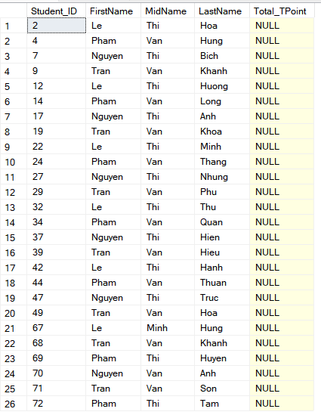

**Question 5 : List the student total classes and calculate the total class credit hour, order by total credit decrease**

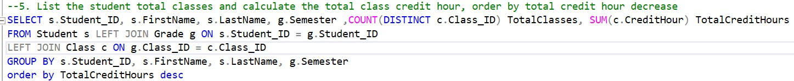

* **SELECT s.Student_ID, s.FirstName, s.LastName, g.Semester** : Selects the student ID, first name, last name, and semester from the `Student` and `Grade` tables.
* **COUNT(DISTINCT c.Class_ID) AS TotalClasses:** Counts the distinct number of classes (`Class_ID`) each student has taken in each semester.
* **SUM(c.CreditHour) AS TotalCreditHours:** Calculates the total credit hours (`CreditHour`) each student has accumulated across all classes in each semester.
* **LEFT JOIN Grade g ON s.Student_ID = g.Student_ID** : Joins the `Student` table with the `Grade` table based on `Student_ID`.
* **LEFT JOIN Class c ON g.Class_ID = c.Class_ID:** Joins the `Grade` table with the `Class` table based on `Class_ID`.
* **GROUP BY s.Student_ID, s.FirstName, s.LastName, g.Semester:** Groups the results by `Student_ID`, `FirstName`, `LastName`, and `Semester`. This allows aggregation of data such as counting distinct classes and summing credit hours for each student in each semester.
* **ORDER BY TotalCreditHours DESC:** Orders the result set by `TotalCreditHours` in descending order, so that students with the highest total credit hours appear first.
* **Result :**

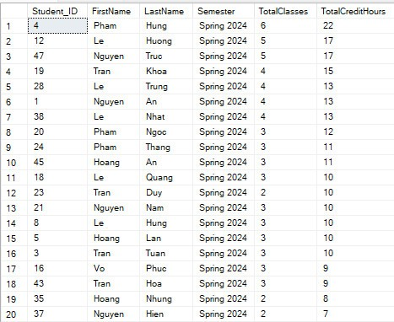

**Question 6 : Create a total fee column in the school fee table, calculate the total fee for each student and add the data in the column. List both the total fee and the students who have paid the fee**

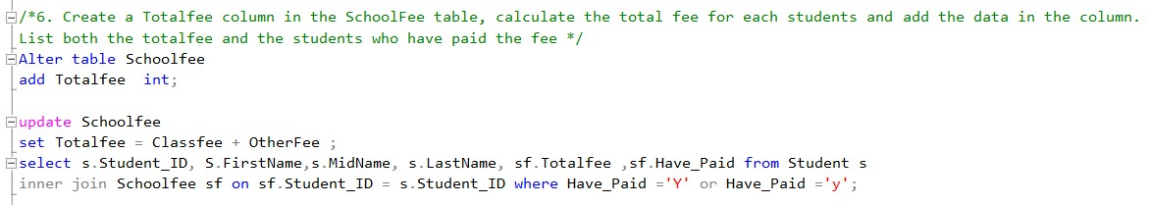

* **ALTER TABLE Schoolfee ADD Totalfee INT :** Add a new column ‘Totalfee’ with datatype is int .
* **UPDATE Schoolfee SET Totalfee = Classfee + OtherFee** : Updates the
* ‘Totalfee ‘ column for each row by summing Classfee and OtherFee.
* **Select ... from Student:** Selects data from the ‘Student’ table.
* **FROM Student s INNER JOIN Schoolfee sf ON sf.Student_ID = s.Student_ID:** Joins ‘Student’ and ‘Schoolfee’ tables on Student_ID.
* **WHERE sf.Have_Paid = 'Y' OR sf.Have_Paid = 'y'**: Filters results to include only students who have paid the fee, accounting for both 'Y' and 'y'.
* **Before:**

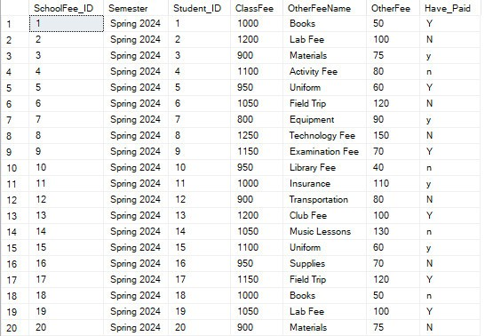

* **After:**

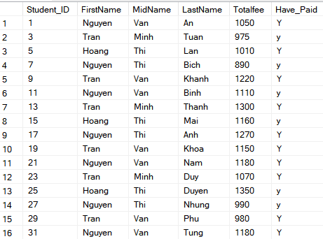

**Question 7 : List all teachers who are teaching at least two different majors and sort them by last name**



* **SELECT t.Teacher_ID, t.Teacher_LastName, t.Teacher_MidName, t.Teacher_FirstName, COUNT(tm.Major_ID) AS NumberOfMajors** : Selects the teacher's ID, last name, middle name, first name, and the count of different majors they teach.
* **FROM Teacher t:** Specifies the Teacher table as the source of the data.
* **GROUP BY t.Teacher_ID, t.Teacher_LastName, t.Teacher_MidName, t.Teacher_FirstName:** Groups the results by the teacher's ID, last name, middle name, and first name to ensure the count is correctly applied per teacher.
* **HAVING COUNT(tm.Major_ID) > 2:** Filters the groups to include only those where the count of majors is 2 .
* **ORDER BY t.Teacher_LastName:** Sorts the results by the teacher's last name.
* **Result :**

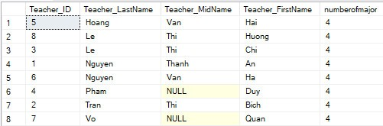

**Question 8 : Calculate the GPA of each student and from that adding the GPA and letter column in the grade table**

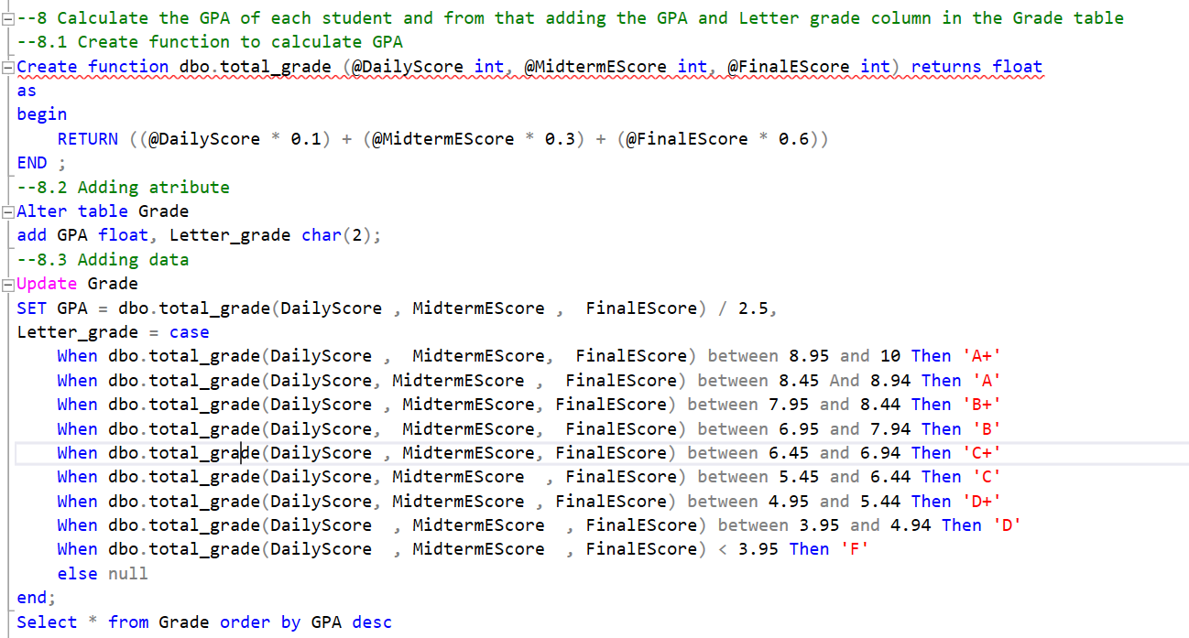





* **CREATE FUNCTION dbo.total_grade**: Defines a function to calculate a weighted average of scores. The function takes **@DailyScore**, **@MidtermEScore**, and **@FinalEScore** as inputs and returns the calculated Grade.
* **ALTER TABLE Grade ADD GPA FLOAT, Letter_grade CHAR(2)**: Adds GPA and Letter_grade columns to the Grade table.
* **UPDATE Grade SET GPA = ...:** Updates the GPA column using the total_grade function and a scaling factor.
* **Letter_grade = CASE ...:** Updates the Letter_grade column based on the calculated GPA using a range-based grading scale use structure CASE in sql .
* **SELECT * FROM Grade ORDER BY GPA DESC:** Retrieves all records from the Grade table, ordered by GPA in descending order.
* **Before:**

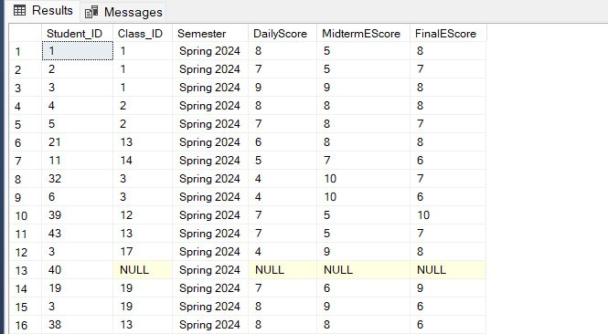

* **After:**

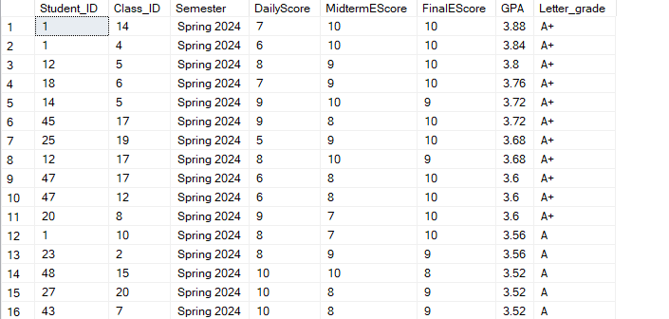

**Question 9 : Using the GPA from the grade table and training points from the student_trainingpoint, select 10 students that have the highest total GPA and training points in a semester qualified for a scholarship, each student will randomly be assigned to a scholarship and add it to the student_scholaship table**

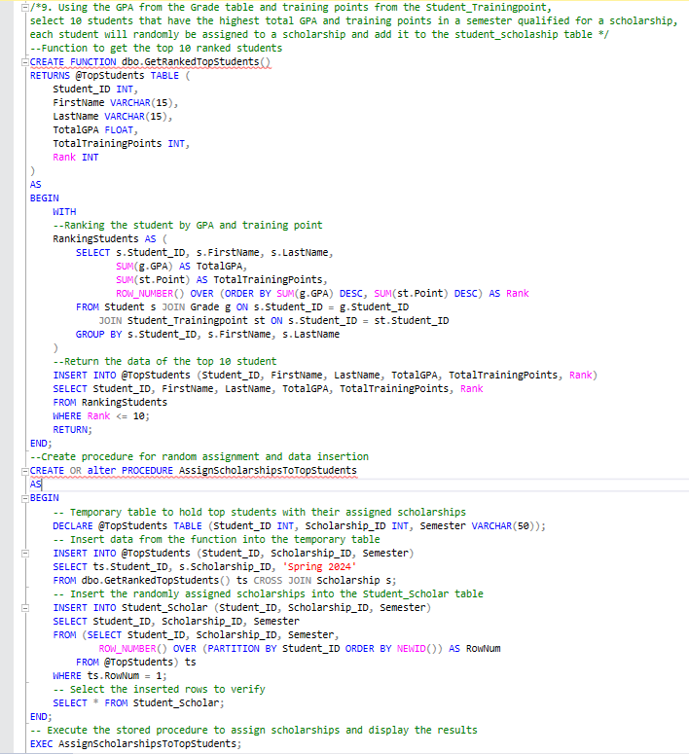

* **CREATE FUNCTION dbo.GetRankedTopStudents():** Create function dbo.GetRankedTopStudents
* **RETURNS @TopStudents TABLE:** Defines the return table with columns for student ID, first name, last name, total GPA, total training points, and rank.
* **WITH RankingStudents AS:** Common Table Expression (CTE) RankingStudents
* **SELECT s.Student_ID, s.FirstName, s.LastName:** Selects the student's ID, first name, and last name.
* **SUM(g.GPA) AS TotalGPA:** Calculates the total GPA for each student.
* **SUM(st.Point) AS TotalTrainingPoints:** Calculates the total training points for each student.
* **ROW_NUMBER() OVER (ORDER BY SUM(g.GPA) DESC, SUM(st.Point) DESC) AS Rank:** Assigns a rank to each student based on the total GPA and training points in descending order.
* **ROM Student s:** Specifies the Student table as the primary data source.
* **JOIN Grade g ON s.Student_ID = g.Student_ID:** Joins the Grade table to associate each student's grades.
* **JOIN Student_Trainingpoint st ON s.Student_ID = st.Student_ID:** Joins the Student_Trainingpoint table to associate each student's training points.
* **GROUP BY s.Student_ID, s.FirstName, s.LastName:** Groups the results by student ID, first name, and last name to ensure the aggregates are correctly calculated per student.
* **INSERT INTO @TopStudents (Student_ID, FirstName, LastName, TotalGPA, TotalTrainingPoints, Rank):** Inserts the selected columns into the @TopStudents table.
* **SELECT Student_ID, FirstName, LastName, TotalGPA, TotalTrainingPoints, Rank FROM RankingStudents:** Selects the columns from the RankingStudents CTE.
* **WHERE Rank <= 10:** Filters the results to include only the top 10 ranked students.
* **RETURN:** Returns the @TopStudents table.
* **END:** Ends the function definition.



* **CREATE OR ALTER PROCEDURE AssignScholarshipsToTopStudents:** Creates or modifies the stored procedure named AssignScholarshipsToTopStudents.
* **AS BEGIN:** Starts the procedure definition.
* **DECLARE @TopStudents TABLE:** Declares a temporary table @TopStudents with columns for student ID, scholarship ID, and semester.
* **INSERT INTO @TopStudents (Student_ID, Scholarship_ID, Semester):** Inserts the selected columns into the @TopStudents temporary table.
* **SELECT ts.Student_ID, s.Scholarship_ID, 'Spring 2024':** Selects the student ID from the top students, the scholarship ID from the Scholarship table, and the semester 'Spring 2024'.
* **FROM dbo.GetRankedTopStudents() ts CROSS JOIN Scholarship s:** Joins the top students from the function with all scholarships.
* **WHERE ts.Student_ID NOT IN (SELECT DISTINCT Student_ID FROM Student_Scholar):** Excludes students who already have a scholarship.
* **INSERT INTO Student_Scholar (Student_ID, Scholarship_ID, Semester):** Inserts the selected columns into the Student_Scholar table.
* **SELECT Student_ID, Scholarship_ID, Semester FROM @TopStudents:** Selects the columns from the @TopStudents table.
* **ROW_NUMBER() OVER (PARTITION BY Student_ID ORDER BY NEWID()) AS RowNum:** Assigns a random row number to each student's scholarship assignment to ensure a random selection.
* **WHERE ts.RowNum = 1:** Filters to include only the rows where the random row number is 1, ensuring each student gets one scholarship.
* **SELECT * FROM Student_Scholar:** Selects all columns from the Student_Scholar table to display the inserted rows for verification.
* **END:** Ends the procedure definition.
* **Result :** After execute the procedure we will get

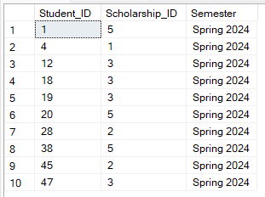

**Question 10 : For the students who have scholarships, the total school fee will deducted by the scholarship prize for the students who haven’t paid the fee yet**

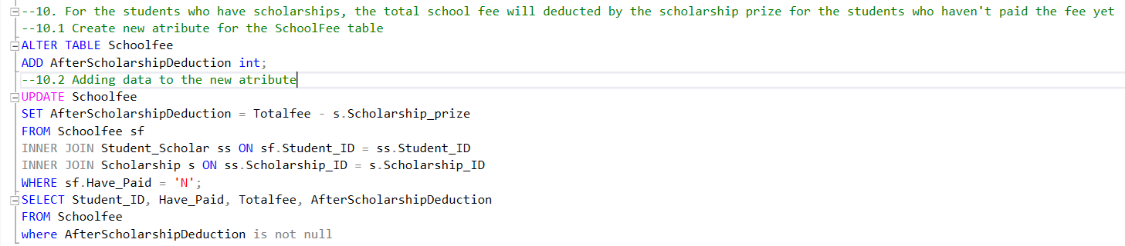



* **ALTER TABLE … ADD:** Adds a new column ‘AfterScholarshipDeduction’ to the ‘Schoolfee’ table. This column will hold the calculated school fee after deducting the scholarship prize for eligible students.
* **UPDATE:** Updates the `AfterScholarshipDeduction` column in the `Schoolfee` table.
* **FROM Clause:** Specifies the tables involved in the update:
* **Schoolfee sf`:** Alias for the `Schoolfee` table.
* **Student_Scholar ss**: Joins `Student_Scholar` table to link scholarships to students.
* **Scholarship s**: Provides access to the `Scholarship` table to retrieve the `Scholarship_prize`.
* **JOIN Conditions:** Connects `Schoolfee` with `Student_Scholar` and `Scholarship` tables based on matching `Student_ID` and `Scholarship_ID`.
* **WHERE Clause:** Filters the update to only those records where `Have_Paid` is 'N', meaning the fee hasn't been paid yet.
* **SET :** Calculates `AfterScholarshipDeduction` as the difference between `Totalfee` (total school fee) and `Scholarship_prize` (amount of the scholarship).
* **SELECT:** Retrieves and displays the `Student_ID`, `Have_Paid`, `Totalfee`, and `AfterScholarshipDeduction` columns from the `Schoolfee` table.
* **WHERE Clause:** Filters the results to show only rows where `AfterScholarshipDeduction` is not null, ensuring that only updated records are displayed.
* **Before:**



* **After:**

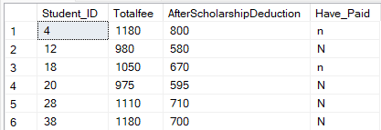

# **CHAPTER 5: CONCLUSION.**

## 5.1. Strengths of the SGM System:

* Comprehensive User Management: Creates a centralized system for student and faculty data, streamlining access and management.
* Improved Organization: Provides a clear overview of academic programs, courses, and faculty, aiding informed decision-making.
* Enhanced Student Performance Tracking: Offers features for managing grades, extracurricular activities, and conduct, promoting well-rounded development.
* Financial Transparency: Tracks tuition fees, invoices, and financial aid, fostering a clear financial experience.
* Strong Communication Features: Facilitates communication between students and teachers through notifications and updates.
* Focus on Data Security: Prioritizes data protection with robust security measures.

## 5.2. Weaknesses of the SGM System:

* Limited Scope: Currently targets a single university (HCMUTE) and may not be scalable to other institutions.
* Focus on Internal Processes: Lacks functionalities that might connect with external systems or applications.
* Unproven Technology: As a new platform, the effectiveness and user-friendliness of SGM remain untested.

## 5.3. Future Improvements for the SGM System:

* Expand Scalability: Develop the system to accommodate multiple universities with diverse needs.
* Integrate External Systems: Explore connections with external learning management systems or student information systems.
* Mobile Application Development: Create a mobile app for SGM to enhance accessibility and convenience.
* Advanced Analytics: Integrate data analytics to generate insights into student performance, course effectiveness, and resource allocation.
* Multilingual Support: Cater to a wider audience by offering the system in multiple languages.